1. Write a python program to implement Simple Calculator program?

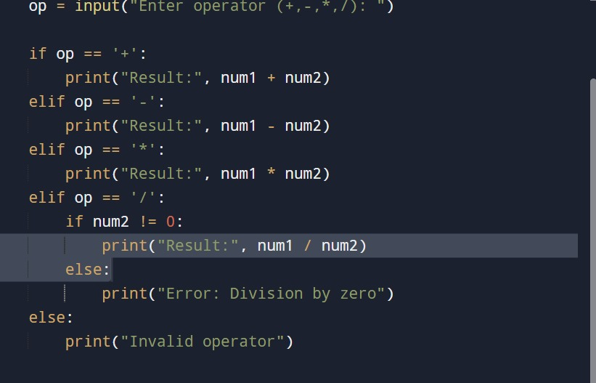

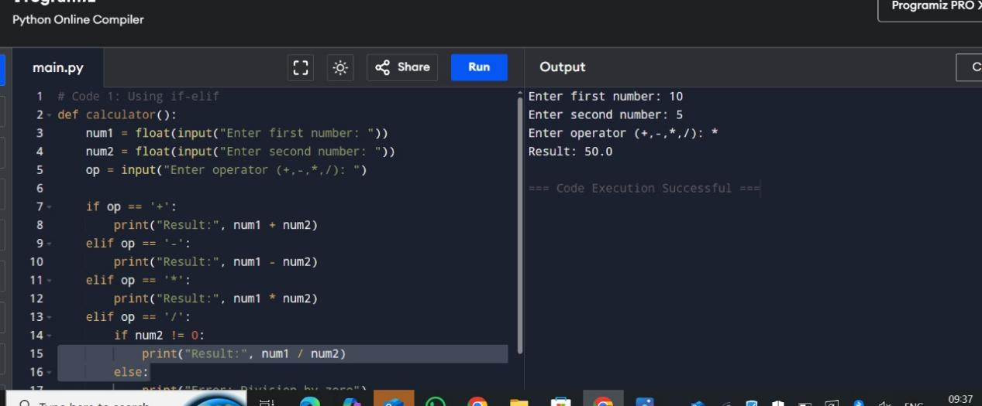

1. Write a python program to Add Two Matrices.

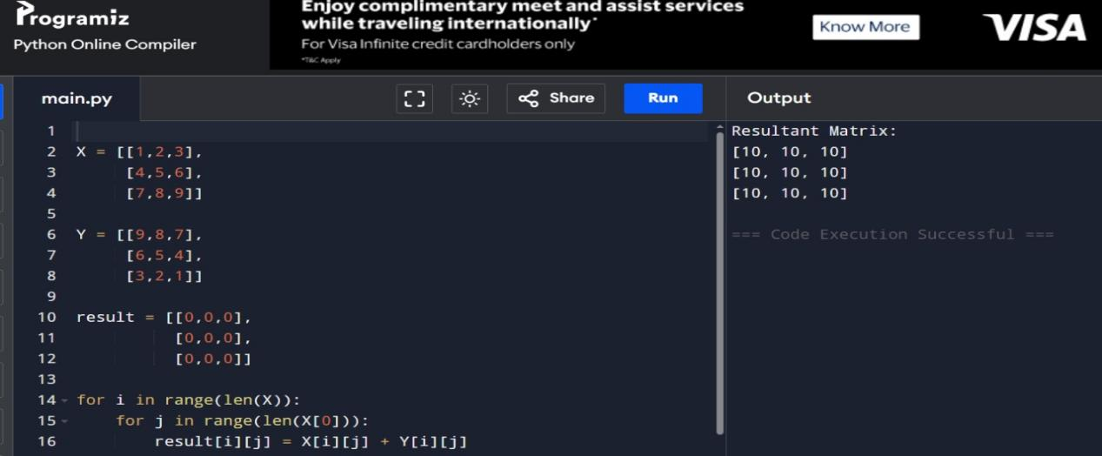

1. Write a python program to Transpose a Matrix.

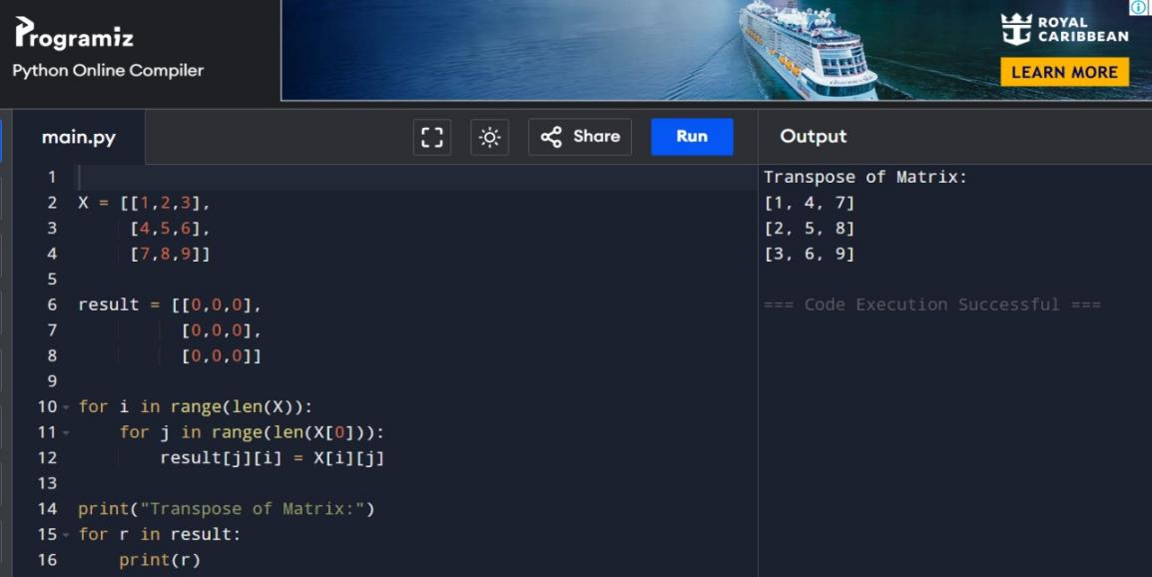

1. Write a python program to sort the sentence in alphabetical order?

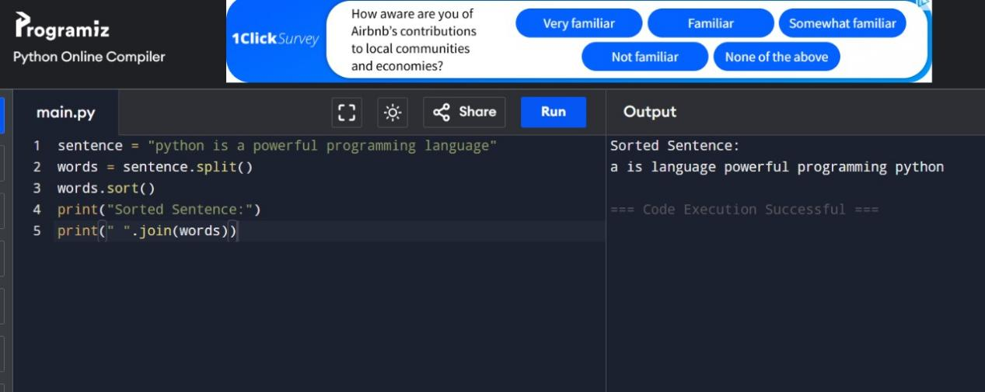

1. Write a python program to implement List operations (Nested List,Length,Concatenation, Membership, Iteration, Indexing and Slicing)?

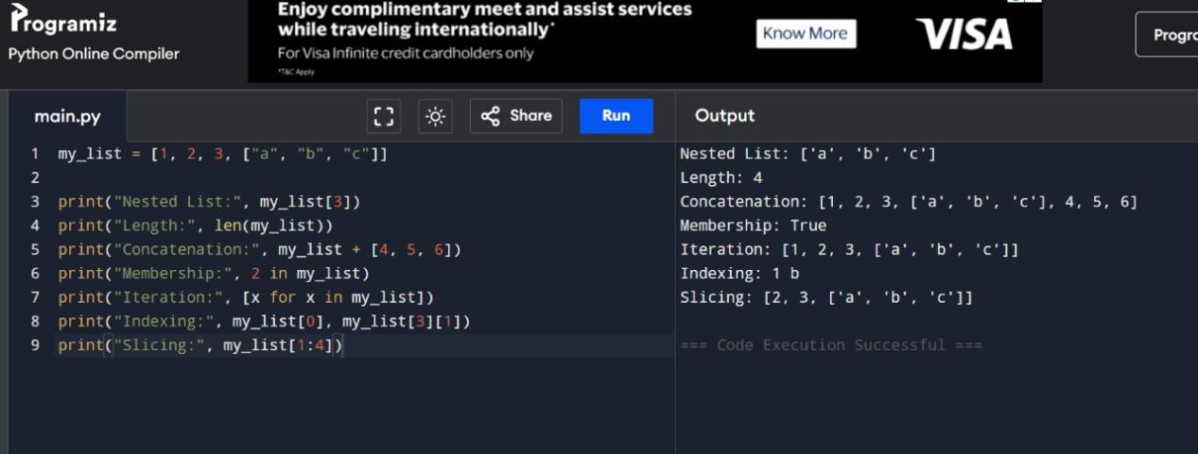

1. Write a python program to implement List methods (Add, Append, Extend & Delete)

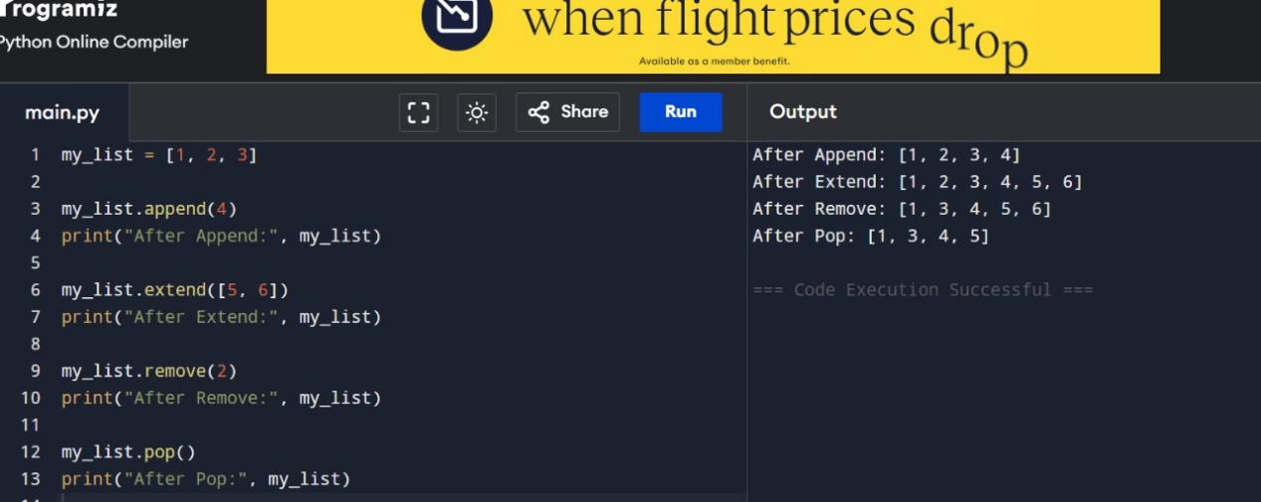

1. Write a python program to Illustrate Different Set Operations?

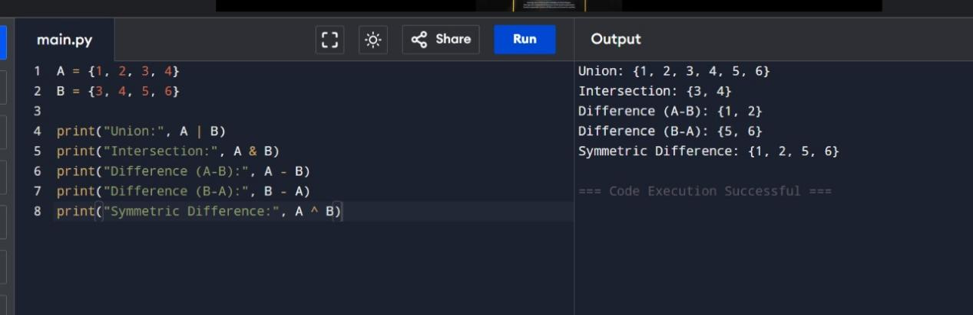

1. Write a python program to generate Calendar for the given month and year?

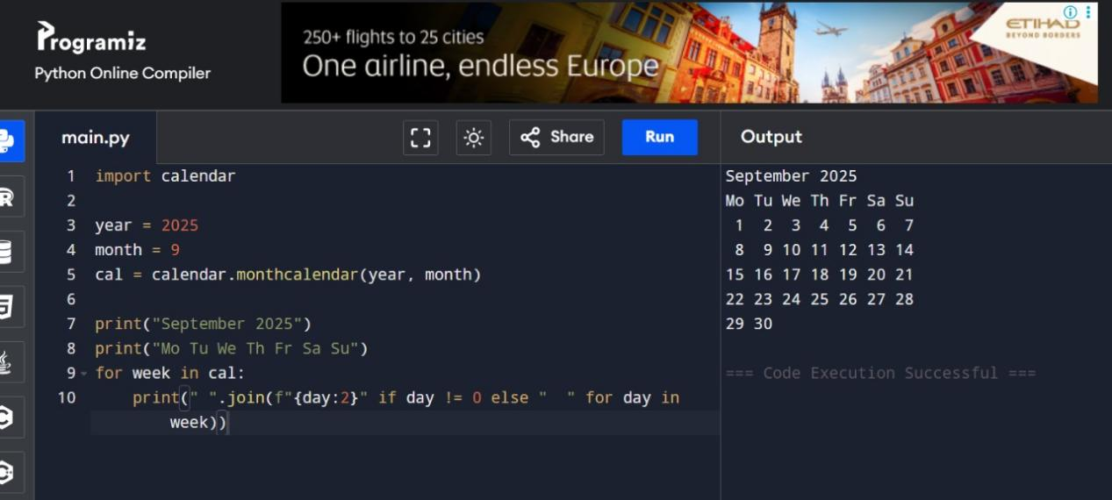

1. Write a python program to remove punctuations from the given string

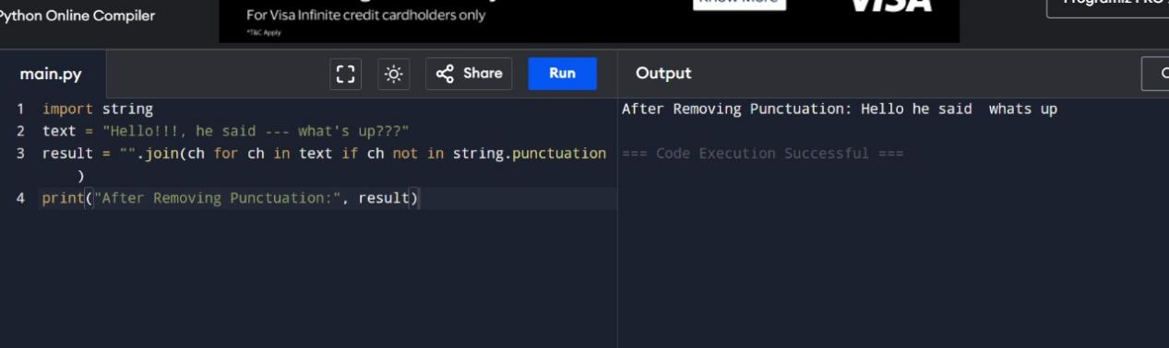

1. Write the python program to solve 8-Puzzle problem

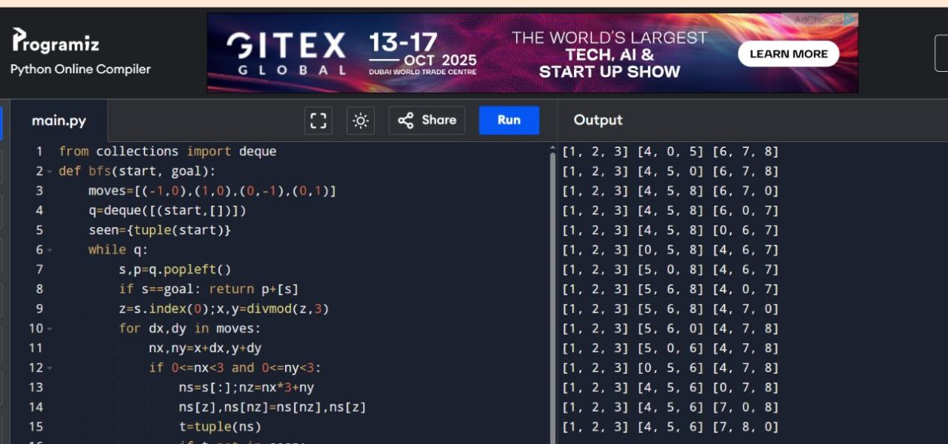

1. Write the python program to solve 8-Queen problem

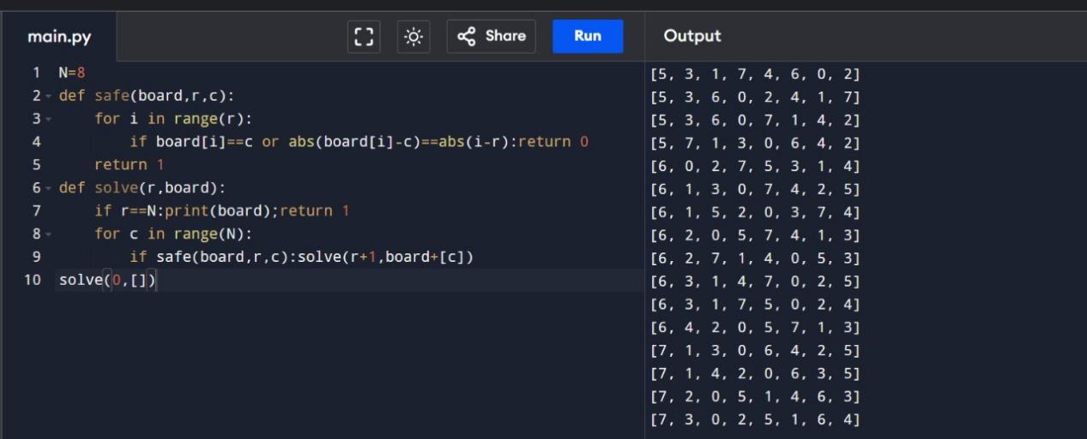

1. Write the python program for Water Jug Problem

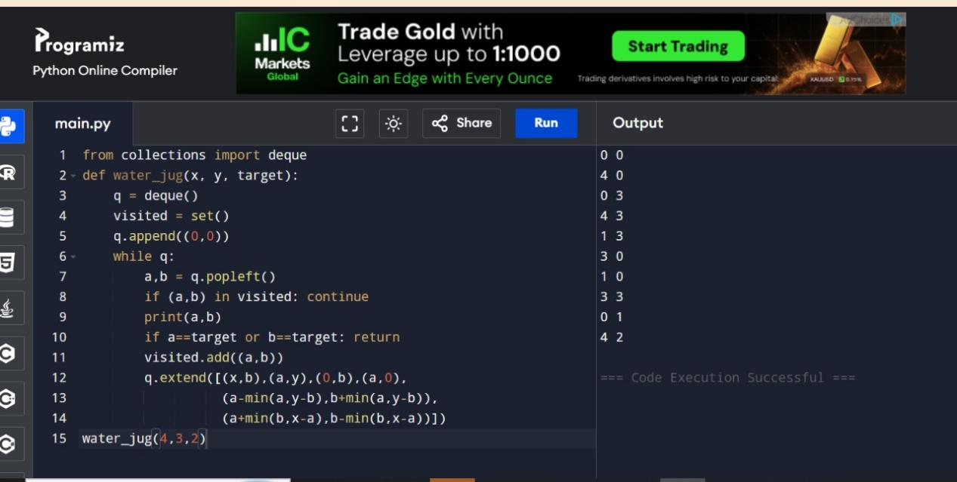

1. Write the python program for Cript-Arithmetic problem

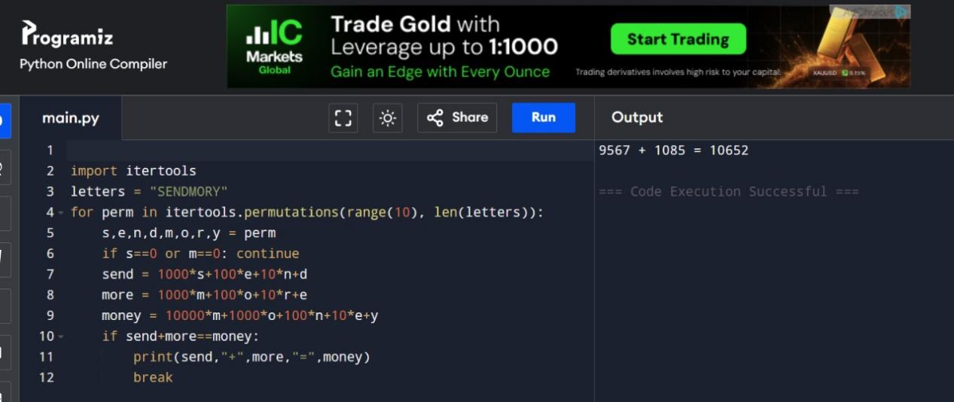

1. Write the python program for Missionaries Cannibal problem

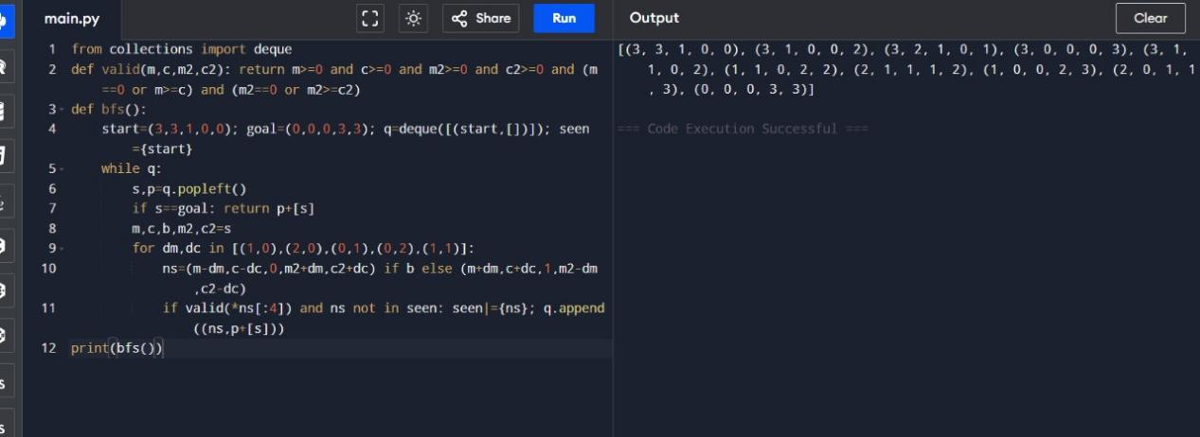

1. Write the python program for Vacuum Cleaner problem

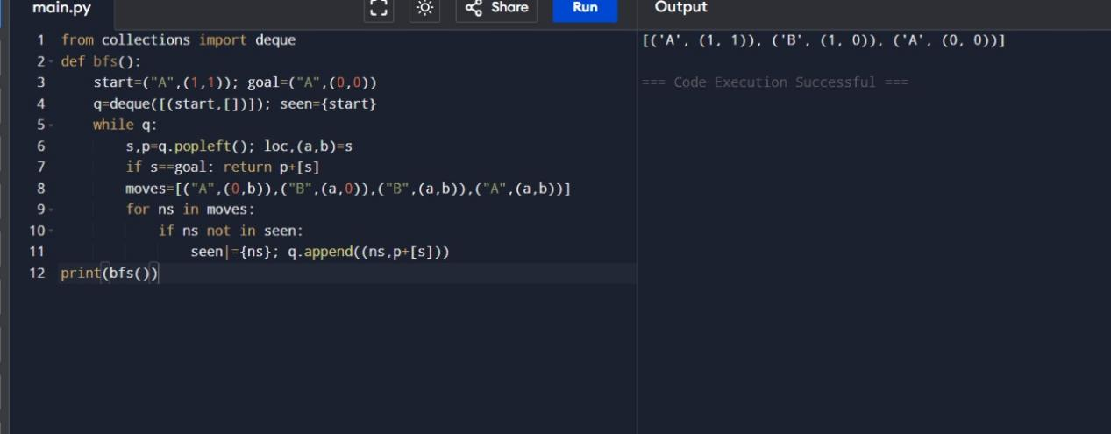

1. Write the python program to implement BFS.

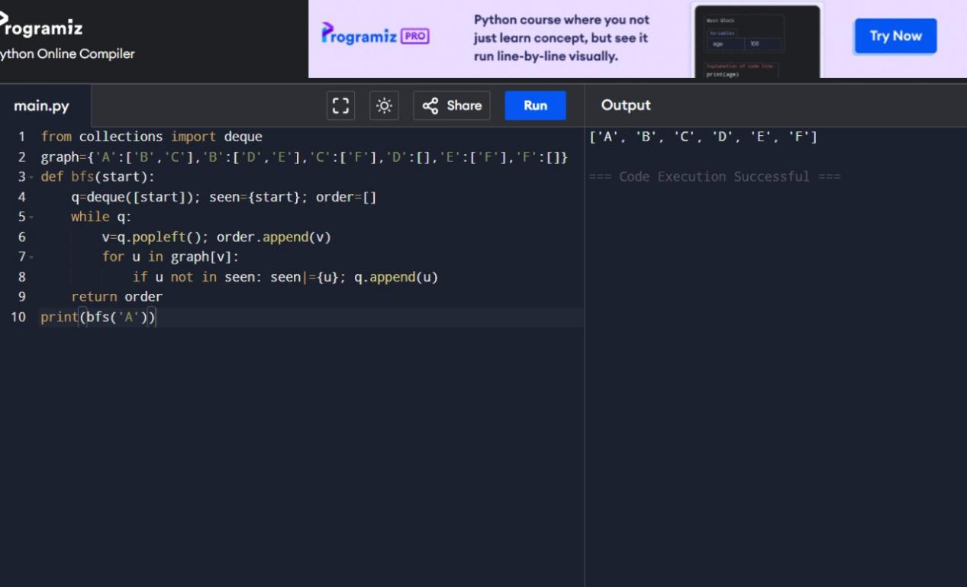

1. Write the python program to implement DFS.

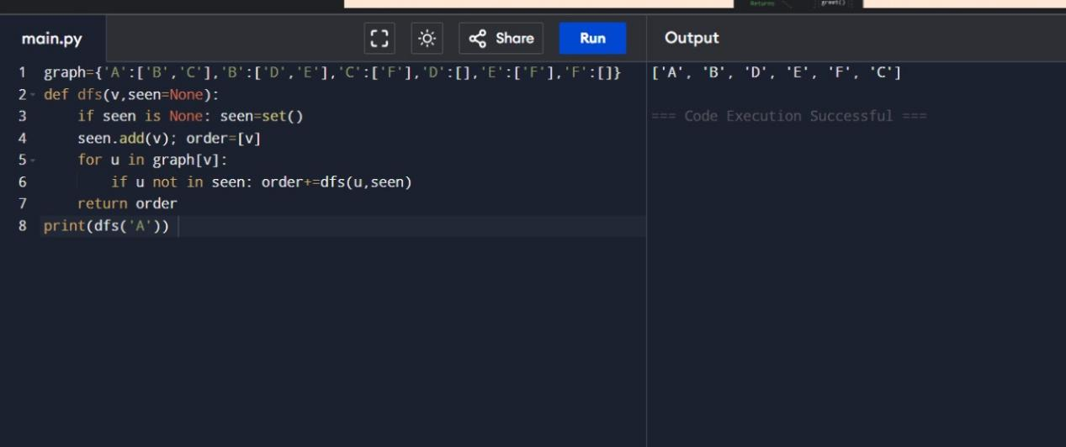

1. Python programming for travelling salesman problem

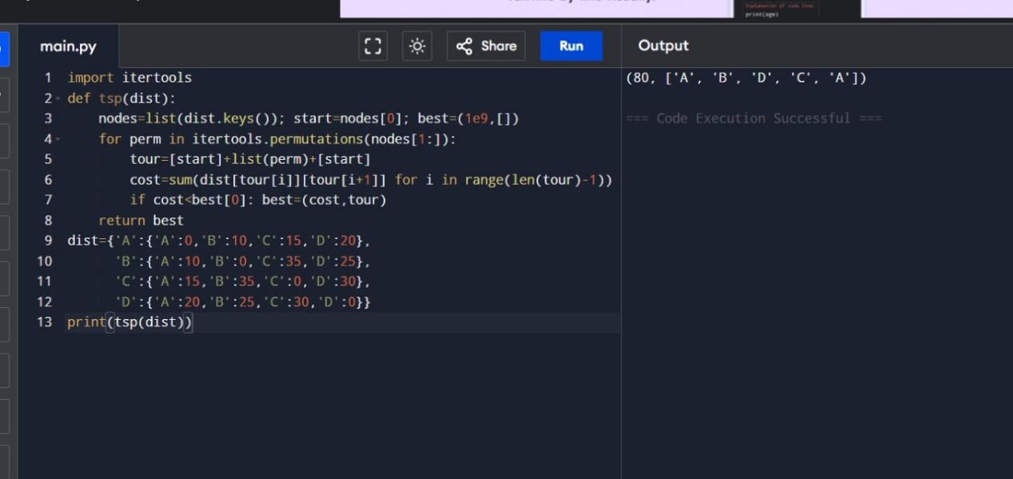

1. Implement A\*algorithm

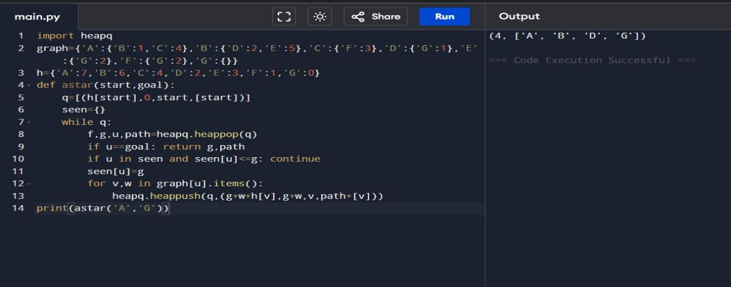

1. Map colouring to implement CSP

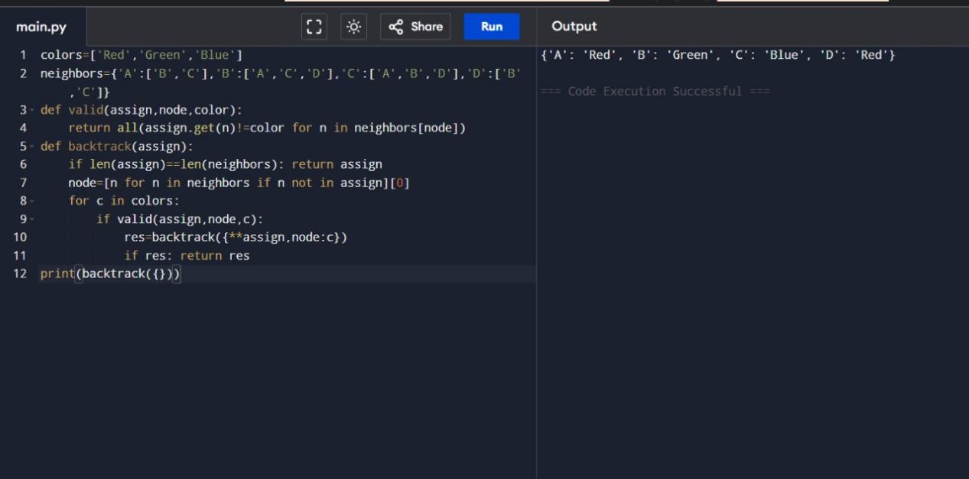

1. Tic Tae Toc game

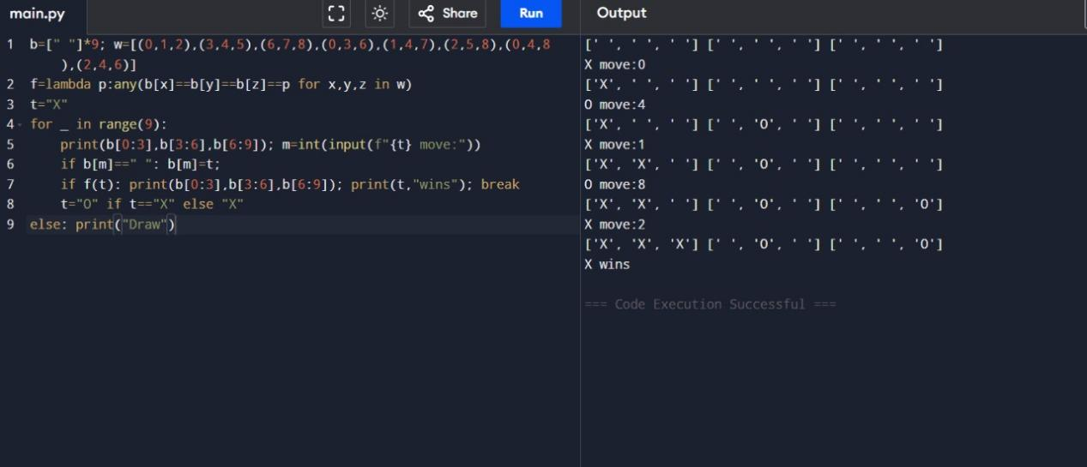

1. Minimax algorithm for gaming

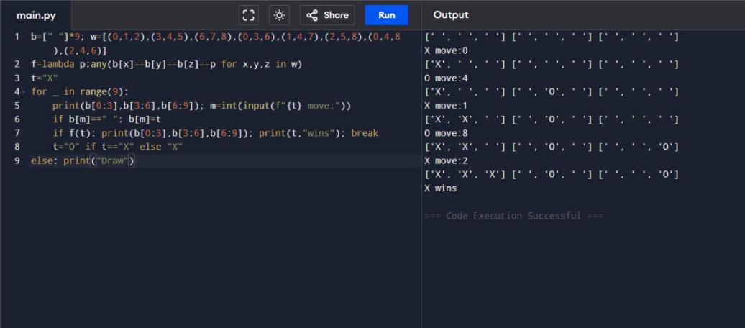

1. Alpha and beta puning algorithm

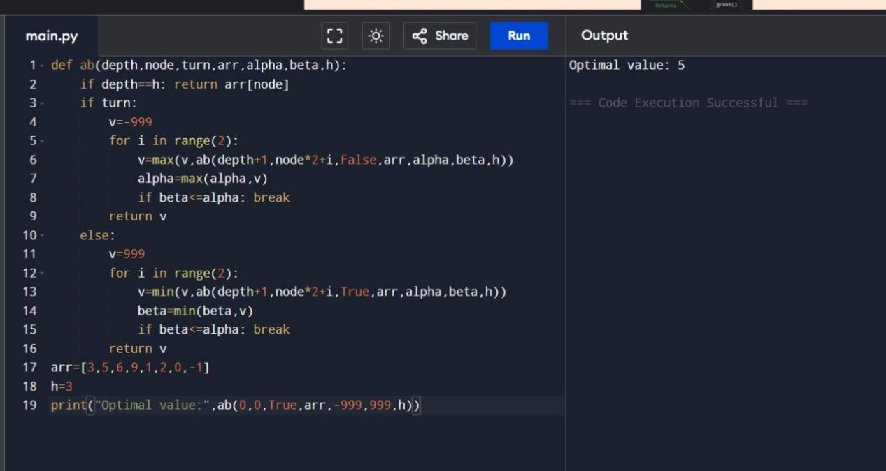

1. Decision tree

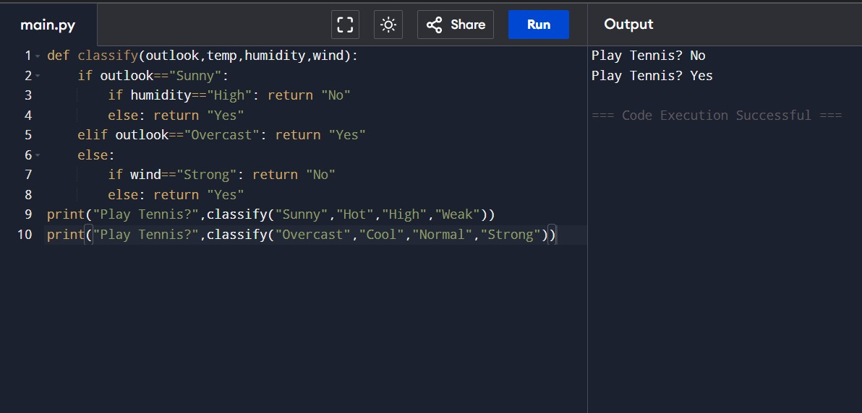

1. Implement feed forward neural network

